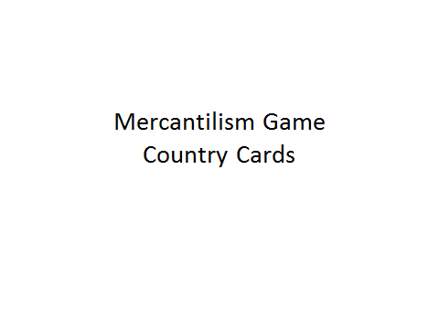
- Set Up:
  - 75 Gold cards, 25 Industry Cards, 70 Raw Material Cards, 125 Food Cards
- Rules:
  - Students must follow the rules of trade restrictions. Colonies can only trade with their parent countries, however, parent countries may trade with each other; i.e. 13 Colonies/South Africa/Australia/India may only trade with England, Canada/Haiti may only trade with France, Mexico/Peru/Cuba may only trade with Spain, but Spain/England/France can trade with each other.
  - Each turn you start with what your card tells you, except for gold. “Gold stays where it lays.”
  - Three countries produce gold and gold is added to the game through these countries. Canada – 1, South Africa – 2, Mexico – 3.
  - Students set their own prices and trade by either bartering or selling for gold.
  - Points are scored at the end of each round.
  - If a country gets five full sets over time; add Industry to base.

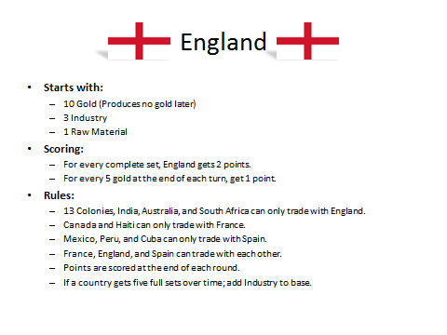
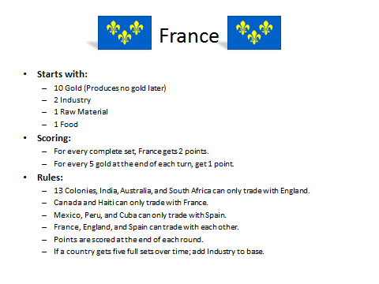
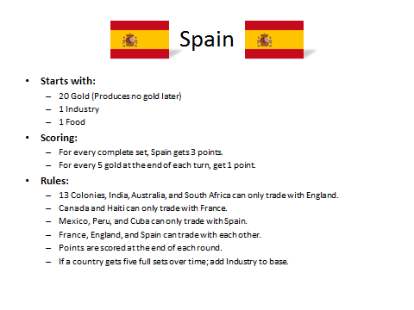
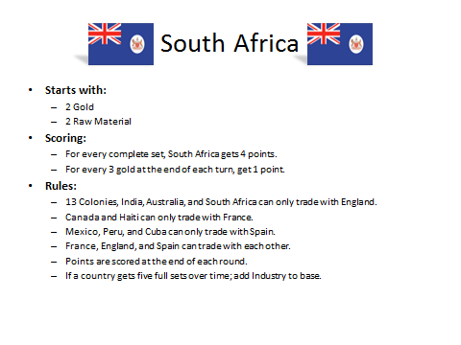
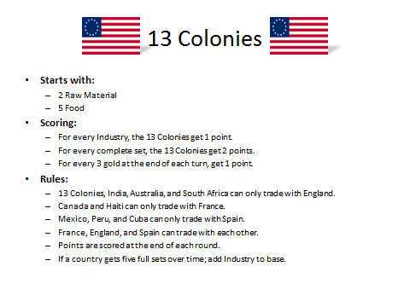
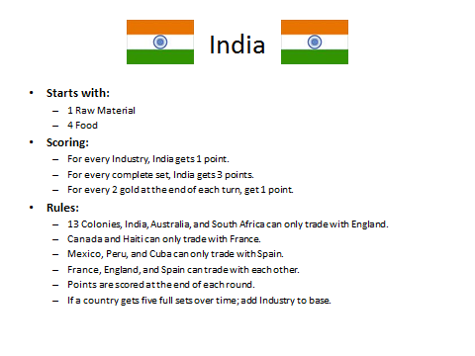
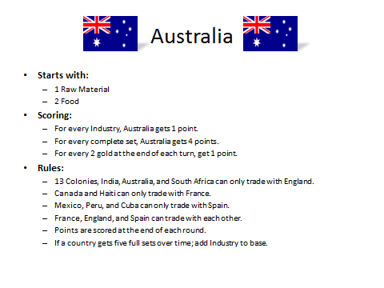
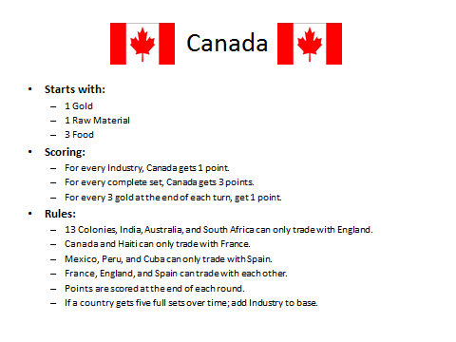
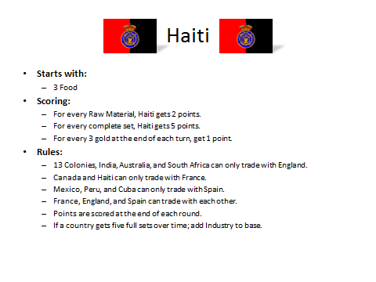
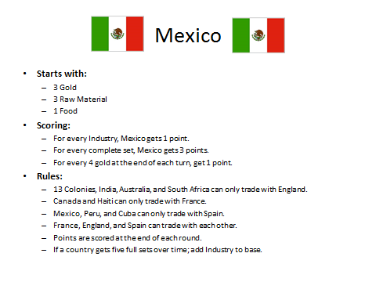
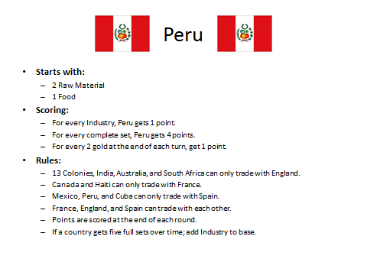
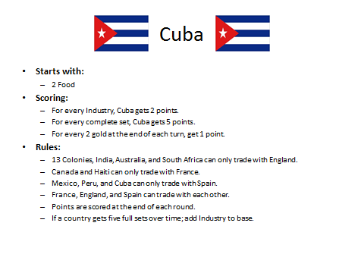
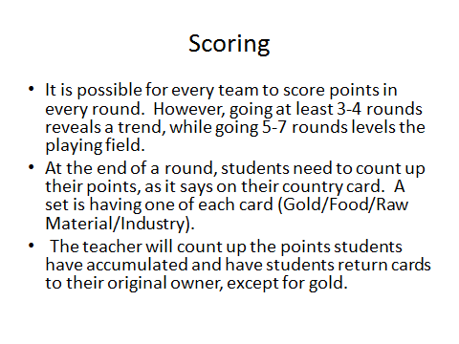

England 
Imperialist Country
Starts with:
- 10 gold (produces no gold)
- 3 industry
- 1 raw material
Scoring:
- England receives two points for every complete set
- England receives one point for every five gold they acquire

Trade partners:
- France (rival country)
- Spain (rival country)
- 13 colonies (colony)
- India (colony)
- South Africa (colony)

France 
Imperial Country
Starts with:
- 10 gold (produces no gold)
- 2 industry
- 1 food
Scoring:
- France receives two points for every complete set
- France receives one point for every five gold they acquire

Trade partners:
- England (rival country)
- Spain (rival country)
- Canada (colony)
- Haiti (colony)

Spain 
Imperial Country
Starts with:
- 20 gold (produces no gold)
- 1 industry
- 1 food
Scoring:
- Spain receives three points for every complete set
- Spain receives one point for every five gold they acquire

Trade partners:
- England (rival country)
- France (rival country)
- Mexico (colony)
- Peru (colony)
- Cuba (colony)

South Africa 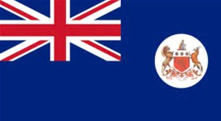
Colonized nation
Starts with:
- 2 gold (producer)
- 2 raw materials
Scoring:
- South Africa receives four points for every complete set
- South Africa receives one point for every three gold they acquire

Trade partners:
- England (mother country)

13 Colonies 
Colonized nation

Starts with:
- 2 resources
- 5 food
Scoring:
- 13 colonies receive two points for every complete set
- 13 colonies receive one point for every three gold they acquire
- 13 colonies receive one point for each industry they acquire

Trade partners:
- England (mother country)

India 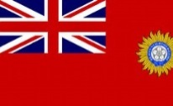
Colonized Nation
Starts with:
- 1 resource
- 4 food
Scoring:
- India receives three points for every complete set
- India receives one point for every two gold they acquire
- India receives one point for each industry they acquire

Trade partners:
- England (mother country)

Australia 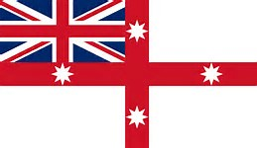
Colonized Nation
Starts with:
- 1 resource
- 2 food
Scoring:
- Australia receives four points for every complete set
- Australia receives one point for every two gold they acquire
- Australia receives one point for each industry they acquire

Trade partners:
- England (mother country)

Canada 
Colonized nation

Starts with:
- 1 gold (producer)
- 3 food
- 1 raw material
Scoring:
- Canada receives three points for every complete set
- Canada receives one point for every three gold they acquire
- Canada receives one point for each industry they acquire

Trade partners:
- France (mother country)

Haiti 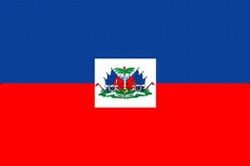
Colonized nation

Starts with:
- 3 food

Scoring:
- Haiti receives five points for every complete set
- Haiti receives one point for every three gold they acquire
- Haiti receives two points for each raw material they acquire

Trade partners:
- France (mother country)

Mexico 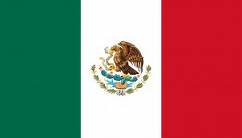
Colonized nation
Starts with:
- 1 food
- 3 gold (producer)
- 3 raw materials

Scoring:
- Mexico receives three points for every complete set
- Mexico receives one point for every four gold they acquire
- Mexico receives one point for each industry they acquire

Trade partners:
- Spain (mother country)

Peru 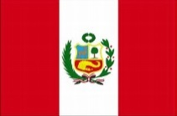
Colonized Nation

Starts with:
- 2 raw materials
- 1 food

Scoring:
- Peru receives four points for every complete set
- Peru receives one point for every two gold they acquire
- Peru receives one point for each industry they acquire

Trade partners:
- Spain (mother country)

Cuba 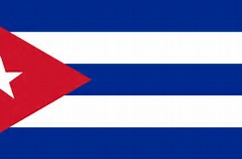
Colonized nation

Starts with:
- 2 food

Scoring:
- Cuba receives five points for every complete set
- Cuba receives one point for every two gold they acquire
- Cuba receives two points for each industry they acquire

Trade partners:
- Spain (mother country)

Food | Food | Food | Food | Food
Food | Food | Food | Food | Food
Food | Food | Food | Food | Food
Food | Food | Food | Food | Food
Food | Food | Food | Food | Food
Food | Food | Food | Food | Food
Food | Food | Food | Food | Food
Food | Food | Food | Food | Food
Food | Food | Food | Food | Food
Food | Food | Food | Food | Food
Food | Food | Food | Food | Food
Food | Food | Food | Food | Food
Food | Food | Food | Food | Food
Food | Food | Food | Food | Food
Food | Food | Food | Food | Food
Food | Food | Food | Food | Food
Food | Food | Food | Food | Food
Food | Food | Food | Food | Food
Food | Food | Food | Food | Food
Food | Food | Food | Food | Food
Food | Food | Food | Food | Food
Food | Food | Food | Food | Food
Food | Food | Food | Food | Food
Food | Food | Food | Food | Food
Food | Food | Food | Food | Food
Raw material | Raw material | Raw material | Raw material | Raw material
Raw material | Raw material | Raw material | Raw material | Raw material
Raw material | Raw material | Raw material | Raw material | Raw material
Raw material | Raw material | Raw material | Raw material | Raw material
Raw material | Raw material | Raw material | Raw material | Raw material
Raw material | Raw material | Raw material | Raw material | Raw material
Raw material | Raw material | Raw material | Raw material | Raw material
Raw material | Raw material | Raw material | Raw material | Raw material
Raw material | Raw material | Raw material | Raw material | Raw material
Raw material | Raw material | Raw material | Raw material | Raw material
Raw material | Raw material | Raw material | Raw material | Raw material
Raw material | Raw material | Raw material | Raw material | Raw material
Raw material | Raw material | Raw material | Raw material | Raw material
Raw material | Raw material | Raw material | Raw material | Raw material
Industry | Industry | Industry | Industry | Industry
Industry | Industry | Industry | Industry | Industry
Industry | Industry | Industry | Industry | Industry
Industry | Industry | Industry | Industry | Industry
Industry | Industry | Industry | Industry | Industry
Gold | Gold | Gold | Gold | Gold
Gold | Gold | Gold | Gold | Gold
Gold | Gold | Gold | Gold | Gold
Gold | Gold | Gold | Gold | Gold
Gold | Gold | Gold | Gold | Gold
Gold | Gold | Gold | Gold | Gold
Gold | Gold | Gold | Gold | Gold
Gold | Gold | Gold | Gold | Gold
Gold | Gold | Gold | Gold | Gold
Gold | Gold | Gold | Gold | Gold
Gold | Gold | Gold | Gold | Gold
Gold | Gold | Gold | Gold | Gold
Gold | Gold | Gold | Gold | Gold
Gold | Gold | Gold | Gold | Gold
Gold | Gold | Gold | Gold | Gold

